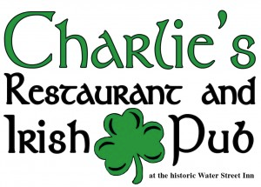

Three-Course Dinner Package

First Course:
- Choose one to share –

Walleye Cakes*
Pan-fried walleye cakes with pepper salsa, lemon remoulade & herb oil.

Spinach & Artichoke Dip
Creamy spinach & artichoke dip, served warm in a bread bowl.

Scotch Egg*
Soft boiled egg wrapped in local pork sausage. Served with remoulade & tossed greens.

Second Course:

Seafood “Chowdah”
A crock of East Coast Style chowder with buttered croutons & chives.

House Salad
Fresh mixed greens and vegetables served with your choice of house-made dressing.

Caesar Salad
Crisp romaine tossed with our house-made Caesar dressing, served with parmesan and croutons

Third Course:

Almond Crusted Walleye*
Pan fried & topped with brown butter. Served with mashed potatoes & local vegetables.

Pappardelle Pasta
House-made pappardelle pasta with tomato ragu & fresh herbs.

Chicken & Parmesan Risotto*
House-made parmesan risotto topped with sautéed chicken breast & fresh herbs.

Grilled Sirloin*
12 oz. Sirloin topped with cippolini onions, served with mashed potatoes & local vegetables.

Many of our Selections can be prepared gluten free. Please ask your server
*The Water Street Inn requests that you please inform your server of any dietary concerns or constraints
*Please note there are health risks involved in consuming raw or undercooked meat and fish

